Group Members:

Muhammad Izham Bin Norhamadi, B032020039, BITZ, S2G1

Ahmad Sha Herizam Bin Tahir, B032020009, BITZ, S2G1

Affendy Elyas Bin Azhari Sharidan, B032020024, BITZ, S2G1

Muhamad Nur Haziq Bin Ainorazahar, B032020034, BITC, S2G1

### Question 1

|  |  |  |  |
| --- | --- | --- | --- |
| Entity | Relationship | Connectivity | Entity |
| TEAM | Has/have | 0:M | PLAYER |
| PLAYER | Has/have | 1:1 | TEAM |
| TEAM | Has/have | 0:M | COACH |
| COAH | Has/have | 1:1 | TEAM |
| PLAYER | Has/have | M:N | PARENT |

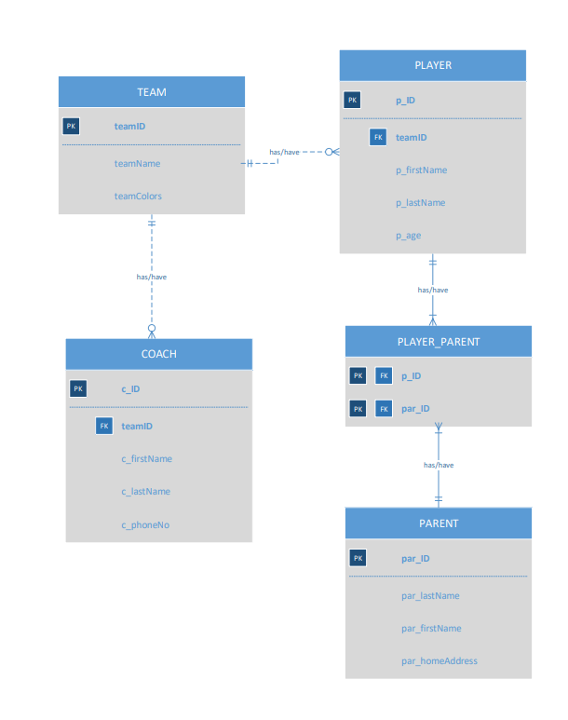

### Question 2

|  |  |  |  |
| --- | --- | --- | --- |
| Entity | Relationship | Connectivity | Entity |
| PUBLISHER | Publish | 0:M | BOOK |
| BOOK | Published by | 1:1 | PUBLISHER |
| BOOK | Written by | M:N | AUTHOR |

### Question 3

|  |  |  |  |
| --- | --- | --- | --- |
| Entity | Relationship | Connectivity | Entity |
| PAINTER | paint | 1:M | PAINTING |
| PAINTING | painted by | 1:1 | PAINTER |
| PAINTING | exhibit | 0:1 | GALLERY |
| GALLERY | exhibit by | 1:M | PAINTING |

### Question 4

|  |  |  |  |
| --- | --- | --- | --- |
| Entity | Relationship | Connectivity | Entity |
| SUBJECT | Taught by | 1:M | LECTURER |
| LECTURER | teaches | 1:M | SUBJECT |
| LECTURER | Belong to | 1:1 | DEPARTMENT |
| DEPARTMENT | have | 1:M | LECTURER |



### Question 5

|  |  |  |  |
| --- | --- | --- | --- |
| Entity | Relationship | Connectivity | Entity |
| COURSE | generate | 0:M | CLASS |
| CLASS | generated by | 1:1 | COURSE |
| INSTRUCTOR | teach | 0:M | CLASS |
| CLASS | teached by | 1:1 | INSTRUCTOR |
| INSTRUCTOR | handle | 0:M | TRAINEE |
| TRAINEE | handled by | 1:1 | INSTRUCTOR |
| TRAINEE | take | 0:M | CLASS |
| CLASS | taken by | 1:1 | TRAINEE |

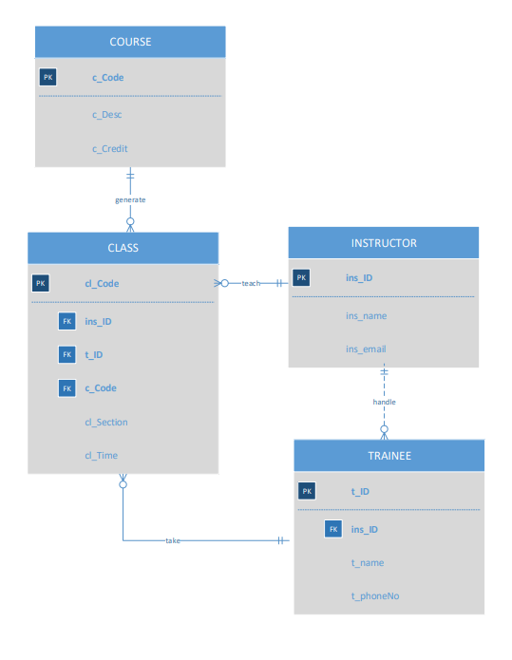

**Describe the relationship between instructor and course in terms of connectivity, cardinality, and existence dependence.**

Each course can generate several classes which is one class can be taught by one instructor only and instructor can teach up to two classes or assigned to do research. Yes, it is has existence dependence. Instructor entity cannot exist if course entity is not exist too and vice versa because class that instructor teach is being generated by the course entity.

### Question 6

|  |  |  |  |
| --- | --- | --- | --- |
| Entity | Relationship | Connectivity | Entity |
| ENTREE | Serves | 1:M | DINNER |
| DINNER | Served with | 1:1 | ENTREE |
| DINNER | Attended by | M:N | GUEST |
| GUEST | Invited by | M:N | INVITATION |

### Question 7

|  |  |  |  |
| --- | --- | --- | --- |
| Entity | Relationship | Connectivity | Entity |
| PROJECT | assigned by | M:N | EMPLOYEE |
| EMPLOYEE | assign | M:N | PROJECT |
| EMPLOYEE | employed by | 1:1 | DEPARTMENT |
| EMPLOYEE | run | 1:1 | DIVISION |
| EMPLOYEE | have | 0:M | DEPENDENT |
| DEPARTMENT | employed by | 0:M | EMPLOYEE |
| DEPARTMENT | Operated by | 1:1 | DIVISION |
| DIVISION | operate | 1:M | DEPARTMENT |
| DIVISION | Run by | 1:1 | EMPLOYEE |
| DEPENDENT | Belong to | 1:1 | EMPLOYEE |

### Question 8

|  |  |  |  |
| --- | --- | --- | --- |
| Entity | Relationship | Connectivity | Entity |
| BRANCH | register/registered by | 1:M | CUSTOMER |
| CUSTOMER | register/registered by | 1:M | BRANCH |
| BRANCH | Has/have | 1:M | STAFF |
| STAFF | HAS/HAVE | 1:M | BRANCH |
| BRANCH | HAS/HAVE | M:M | VIDEO |
| VIDEO | HAS/HAVE | M:M | BRANCH |
| VIDEO | MANAGED BY | M:M | STAFF |
| STAFF | MANAGE | M:M | VIDEO |
| CUSTOMER | RENTS/RENTED BY | 0:M | RENTAL |

